Women’s Moto Expedition in the Himalayas: High Fives Over the High Passes
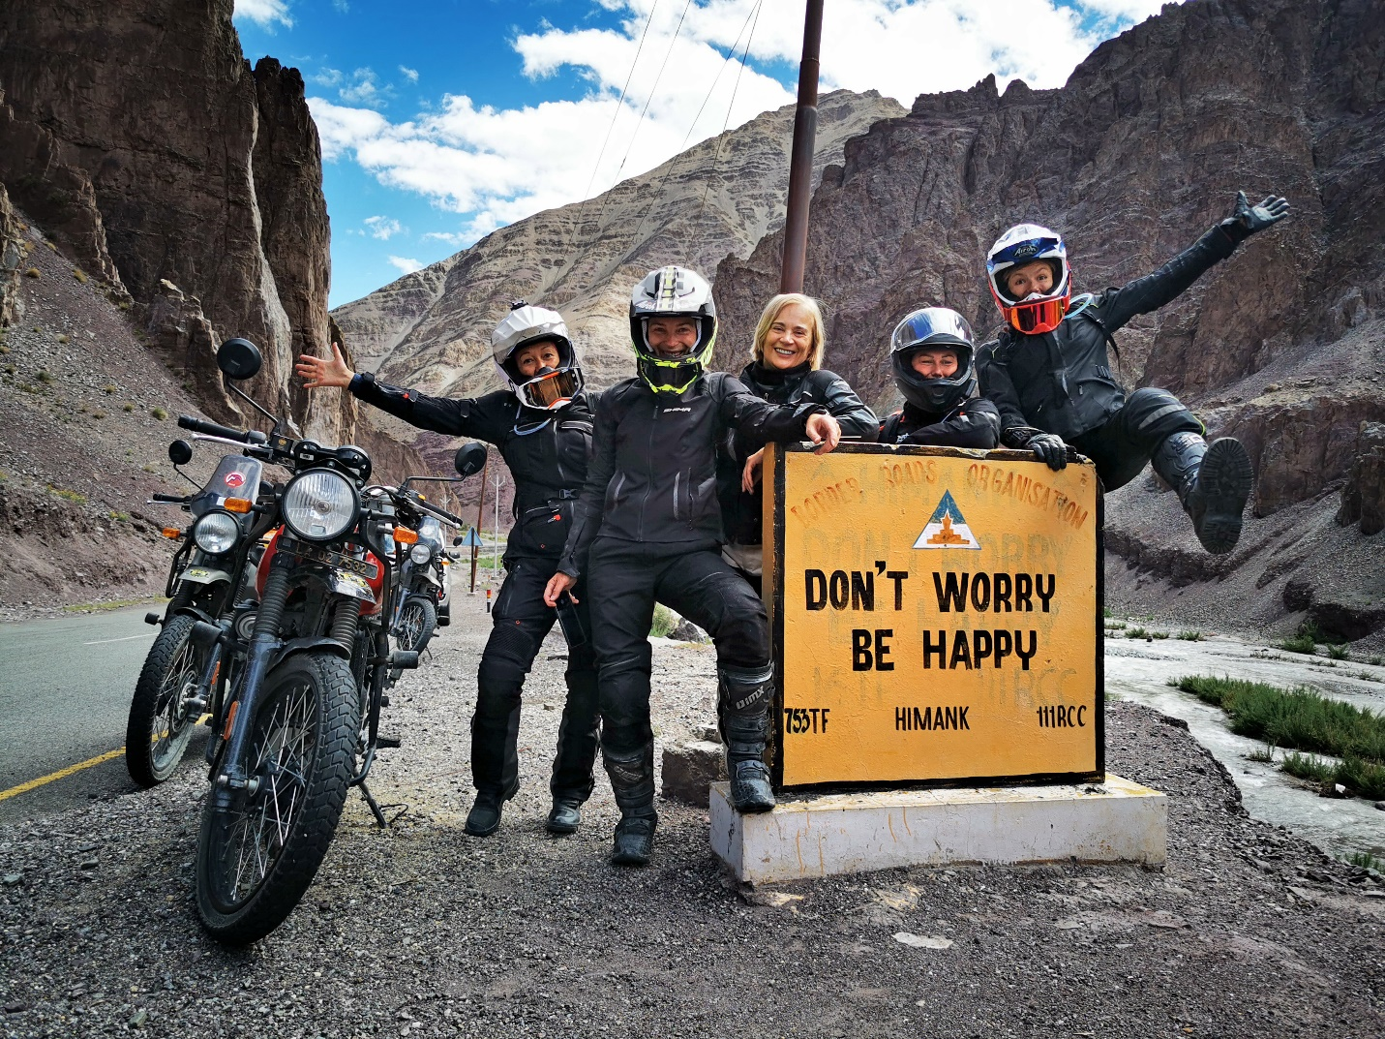
Date: August 20-30
Riding level: mid-level
Bikes: Royal Enfield Himalayan
Guides: Egle, Alexandra
On Road/Off Road: 50/50
Intro:
Ride the Himalayas with us! That’s right, we’re headed to Northern India this August, and it’s going to be one hell of a ride as we’ll tackle some of the highest Himalayan passes, experience the local Buddhist culture, and ride Royal Enfield Himalayan bikes with a crew of badass women.
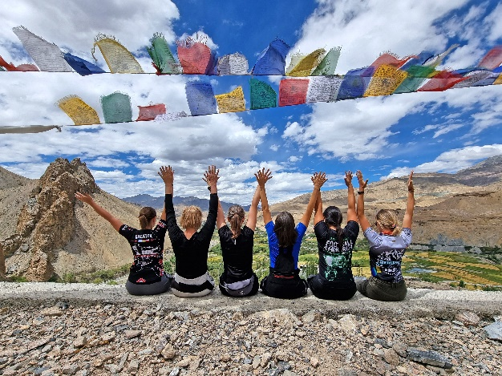
This is a true expedition – we’ll travel through the famous Khardung-La pass, overnight in simple local homestays, cross the Nubra Valley, and take in the stunning Himalayan views from the saddles of our motorcycles. We’ll be riding India with an international team of female riders: for this adventure, we’re partnering up with our good friend Alexandra, founder of Motobirds, and we can’t wait to see what the Himalayas have in store for us.
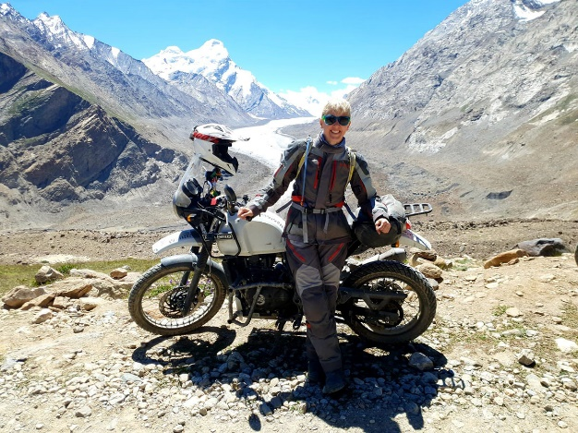
As Alexandra explains it, this tour is designed for women who have some off-road riding experience and who are looking for challenges and do not shy away from more basic accommodations. This is best described as a roller coaster motorbike ride: from the Buddhist monasteries of Ladakh, the mysterious Zanskar Valley, and high-altitude desert landscapes, we will head straight up to the highest motorable passes in the world and explore routes that have only opened up recently and have not been part of any organized tour before. The route covers all of the highlights of the ancient Buddhist kingdom of Ladakh as well as the most beautiful Himalayan lakes in the border region with Tibet.
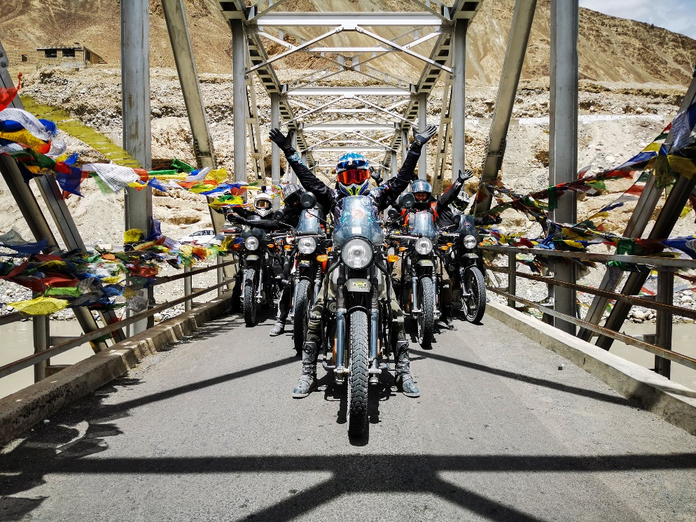
Sound like your kind of thing? Join the adventure!
Dates: August 20-30 Price: EUR 3150 €
Book safely with MOTOBIRDS:
https://motobirds.com/en/product/himalayas-women-only-20-30-08-2023/
DAILY MILES AND DESTINATIONS:
DAY 1: Welcome! ARRIVAL TO LEH
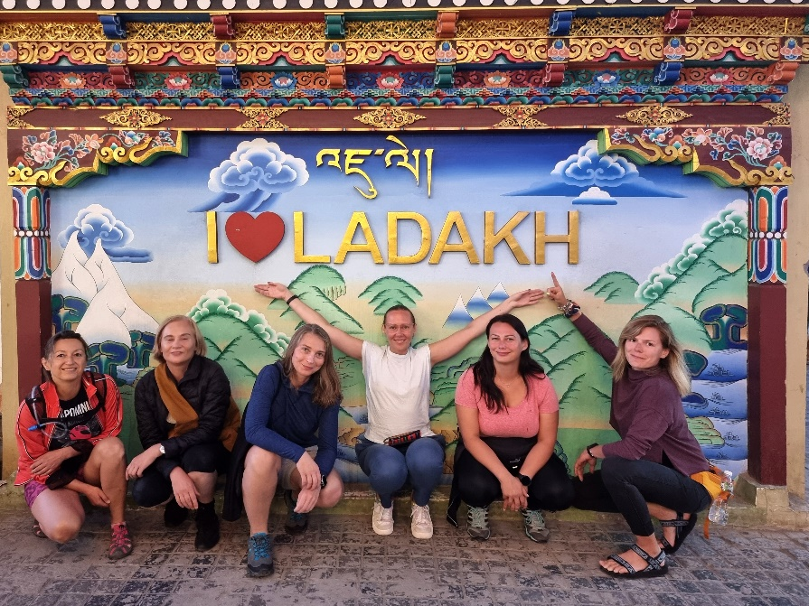

DAY 2 (115 KM) LEH – LAMAYURU
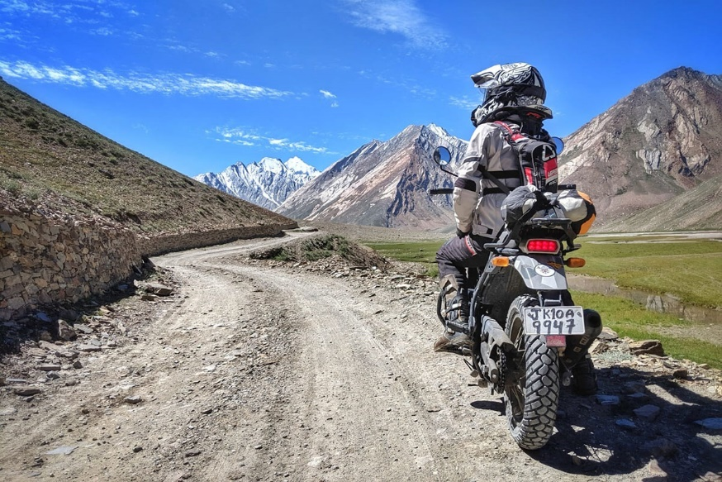
DAY 3 (210 KM) LAMAYURU – PADUM
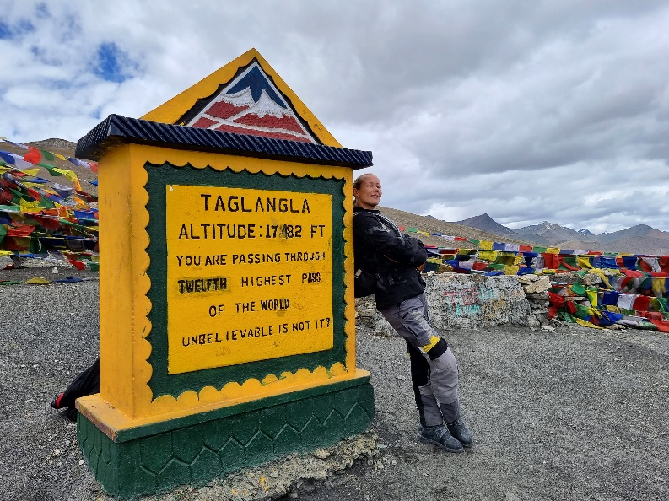
DAY 4 (183 KM) PADUM – JISPA
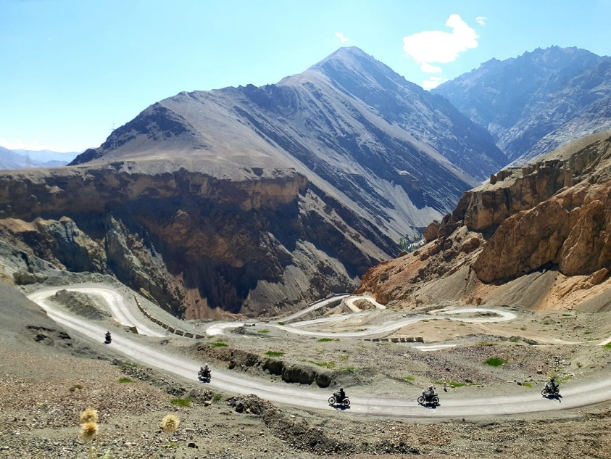
DAY 5 (215 KM) JISPA – TSO KAR
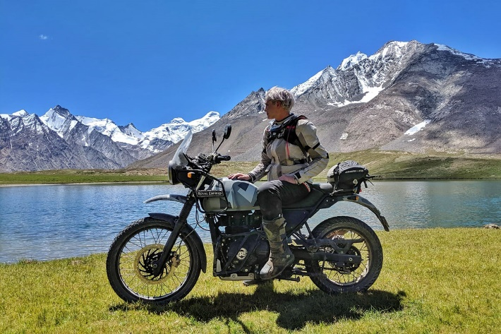
DAY 6 (165 KM) TSO KAR – TSO MORIRI – NYOMA
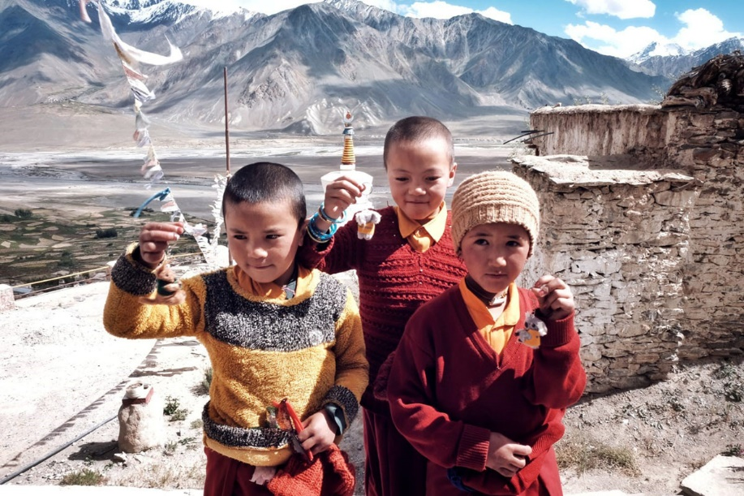
DAY 7 NYOMA – UMLING LA – HANLE
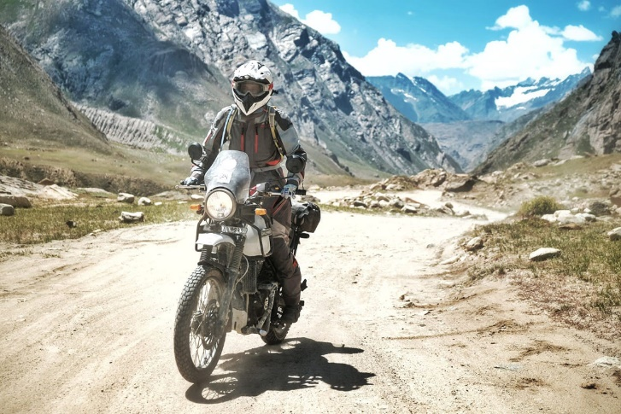
DAY 8 (145 KM) HANLE – PANGONG TSO LAKE
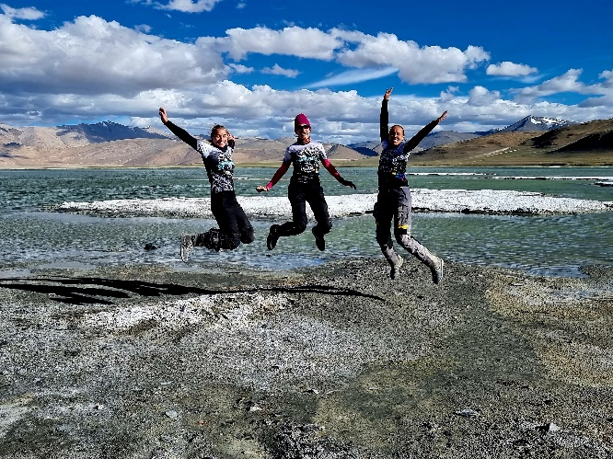
DAY 9 (135 KM) PANGONG TSO LAKE – NUBRA VALLEY
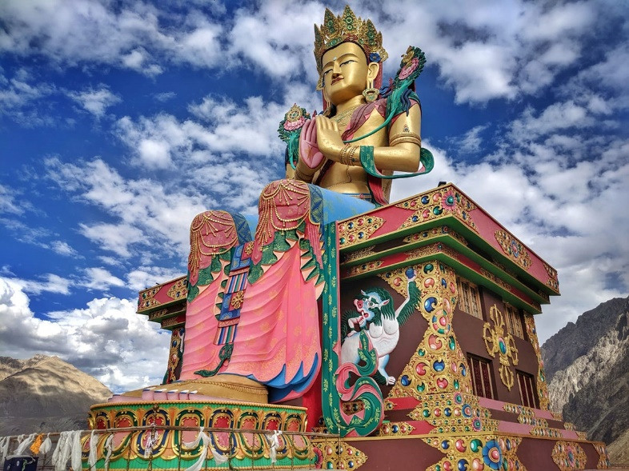

DAY 10 (160 KM) NUBRA VALLEY – LEH
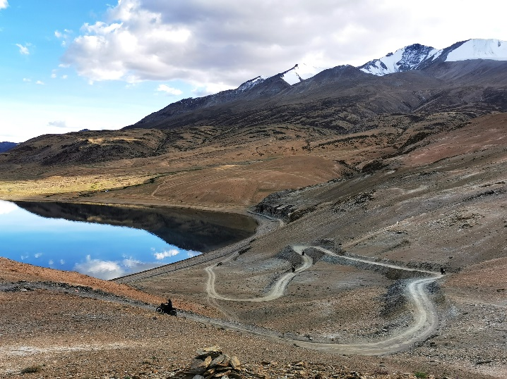
DAY 11 LEH – DEPARTURE
Note that the route may change due to unforeseen weather, social, or political factors.
TOUR HIGHLIGHTS:
- A new route connecting Zanskar Valley and Manali
- Ladakh Buddhist Monasteries
- Nubra Valley
- Khardung La Pass (5,359 m)
- Shingu La Pass (5,091 m)
- Chang La Pass (5,360 m)
- Lachung La Pass(5,019 m)
Just how difficult is the riding going to be – is this tour for me?
The Himalayan expedition does require you to have some off-road experience: if you feel comfortable enough on gravel, forest service roads, and a little bit of sand here and there, you’ll do great! This tour isn’t difficult in terms of riding – we will mostly stick to paved and gravel roads rather than anything technical – but we will be riding at high altitude which adds to fatigue, so you’ll need some endurance. Don’t overthink it, though - we’ll all support you and cheer you on along the way!
WEATHER:
As they say, if you don’t like the weather in the Himalayas, just wait for a few hours… The Himalayas are so high that they create microclimates in each valley, and the weather conditions may change very fast. It can be bright and sunny one moment, and a few hours later, it could get cloudy and cold. Our tour is taking place during the most favorable time of the year in terms of weather conditions, however, it is very difficult to predict the temperatures. You have to be prepared for all kinds of conditions: days with bright sun shining, sudden gusts of strong cold winds, and cold nights. Wear good, four-season riding gear for this one!
LUGGAGE:
We will be traveling light. Your luggage will be transported in the chase truck, but please keep it under 20kg – and it’s best if your bags are dust and water-proof. For everyday items during the ride, we suggest strapping a small waterproof bag to the back of your bike.
What’s included in the tour price:
- Motorcycle rental (Royal Enfield Himalayan)
- 4x4 chase vehicle
- Accommodation (hotels, guesthouses, and family homestays in twin or triple share rooms). Note: a large part of the tour crosses remote, off-the-beaten-path areas where accommodation will be basic – neat and clean, but urban luxuries, hot showers, lavish buffets and central heating may not be available. What these places lack in amenities they make up for with an authentic experience, organic locally sourced food, and heart-warming hospitality. Single-room upgrades are available for an additional fee of 70 EUR/night.
- Breakfast, lunch, and dinner meals (except for lunch and dinner meals in Leh)
- Airport transfers. Group airport transfers are included in the tour price, provided your arrival date is on the tour program dates. Individual transfer can be organized on different dates but is not included in the tour price (individual transfer fee: 30 EUR).
- Insurance. Basic travel insurance and motorcycle insurance. Upon request and with an additional fee, we can offer additional insurance, covering the costs related to no–show on the tour due to Covid -19. Tourist Guarantee Fund fee. Tourist Support Fund fee.
What’s not included:
- Flights
- Tourist entry visa (if required – depending on your origin country)
- Fuel
- Adult beverages
- Covid tests and/or vaccinations, if required.
- Medical expenses not covered by MotoBirds insurance.
- Costs related to the transport of a participant to the nearest medical center, in case of injury or illness or inability to continue the tour.
- Costs related to the transport of the participant’s motorcycle to the finish point of the tour, in case the motorcycle or the participant cannot continue the tour.
- Lunch and dinner meals in Leh
- Entry tickets to the optional tourist attractions, i.e. Buddhist monasteries.
- Motorcycle refundable security deposit of 500 USD, payable in cash on the first day after arrival.
IMPORTANT:
Each participant is required to arrange a tourist entry visa to India for herself.
We will be traveling at very high altitudes, so be sure you carry sunscreen and sunglasses.
During your tour, especially when crossing the highest mountain passes, you may feel symptoms of altitude sickness (AMS). Remember that you must drink a lot of water to minimize this risk. In case you feel sick, we will have an oxygen cylinder with us.
All tour participants must hold a valid motorcycle license.

